**SYLLABUS - AERONAUTICAL ENGINEERING: PRINCIPLES OF FLIGHT 2021-2022AY**

Mr. Yakawich, Rm 140B, Phone: 728-2403 x 7075, Email: JYakawich@mcpsmt.org

**Course Description**

In this AOPA (Aircraft Owners and Pilots Association) course, students explore different types of aircraft, their function and construction design. Students will gain an in-depth understanding of the forces of flight, stability, and aircraft controls including how to make key calculations. Aircraft systems such as electrical, fuel, landing gear, and environment are also investigated as well as the identification and troubleshooting of common in-flight problems. In addition to exploring careers in aviation and aeronautics, students eventually design and model their own aircraft.

**Course Goals**: The overarching goal of this program is to introduce the students to the field of Aviation and Aeronautical engineering. Students will improve problem-solving and critical thinking skills while exploring:

* Aircraft components and materials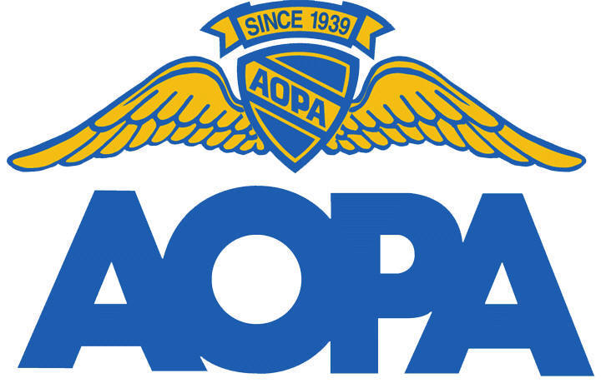
* Air forces impacting flight
* Fluid dynamics
* Airfoil design and theories of lift
* Propulsion systems
* Airframe systems (electrical, hydraulic, and pressurization)
* Flight controls
* Aircraft design

**Text**: No text is required; however, students will access Google Classroom for materials and instruction.

**Required Materials**: Dedicated course binder, pencil, and pen.

**Availability**: My mission is to help you succeed. I am typically available an hour before and after school hours, during lunch periods, and by appointment. Don’t struggle alone. Take responsibility for your learning. Ask for help in a timely manner. I am here to help you succeed.

**Policies**: Refer to Student Handbook and MCPS policies.

**Expectations**: In this class, you are expected to model those skills necessary to be a respectful, responsible, and engaged citizen. As such, **be honest and kind**, treat others as you would like to be treated, be on time to class with the appropriate equipment, and participate—you are a member of a team. The use of hats, hoods, earbuds, and cell phones are not permitted in this classroom.

**Grading**: Standard grading: less than 60% (F), 60-69% (D), 70-79% (C), 80-89% (B), 90-100% (A).

• Projects and Assignments – 70% (*Collaboration, contribution, and participation also scored per rubric)

• Binder/Notebook, notes, and organization – 10%

• Assessments (quizzes and tests)- 20%

Late work: accepted until the end of the quarter for up to 50% credit. Manage your time wisely.

**Lab Safety**: Our room & build area is a lab where you will engage in many building projects. It is essential all engineers follow lab safety guidelines. Failure to follow instructions will result in removal from lab and zero project credit.